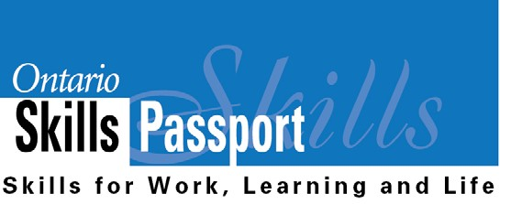
Ontario Skills Passport Reflection
Worksheet

Name: Date: Volunteer Experience at School:

Who am I? | What Essential Skills and work habits did I develop and demonstrate?  What did I learn about myself from this experience?
What are my opportunities? | What other experiences can I pursue that can help me apply and further develop my Essential Skills and work habits?
Who do I want to become? | How do my Essential Skills and work habits prepare me for the types of occupations that I have identified in my goals?
What is my plan for achieving my goals? | Are there any Essential Skills and work habits that I need to further develop to achieve these goals?  What is my next step to further develop my Essential Skills and work habits?

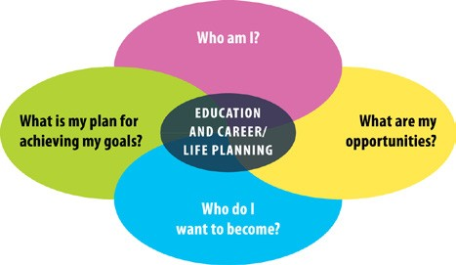
Save this reflection in your “All About Me” portfolio.

ontario.ca/skillspassport

